

**THE INTERNSHIP TEST**

***Time: 60 minutes***

**1.** Identify the missing square

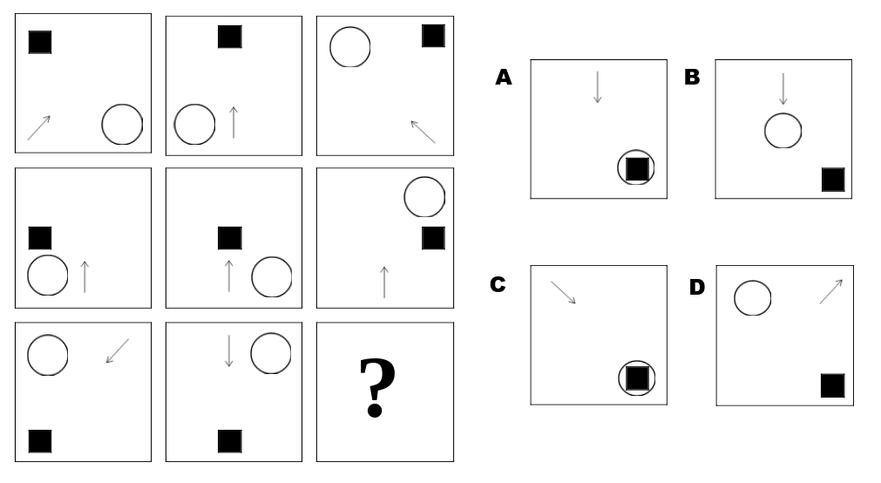

=>  Answer **C**

There are three rules to spot in this question. Firstly, there is a relative positional rule: the position of the black square corresponds to the position its square holds within the diagram.

Secondly, there is a movement rule, in that the circle moves around the boxes in a clockwise position. Finally, the arrows in the first and third columns are reflections of one another. The correct answer is therefore **C**.

**2.**

1 + 4 = 5

2 + 5 = 12

3 + 6 = 21

8 + 11 = ?

Answer: **96** by a + b => a + ab

**3.** Find the number which replaces the question mark.

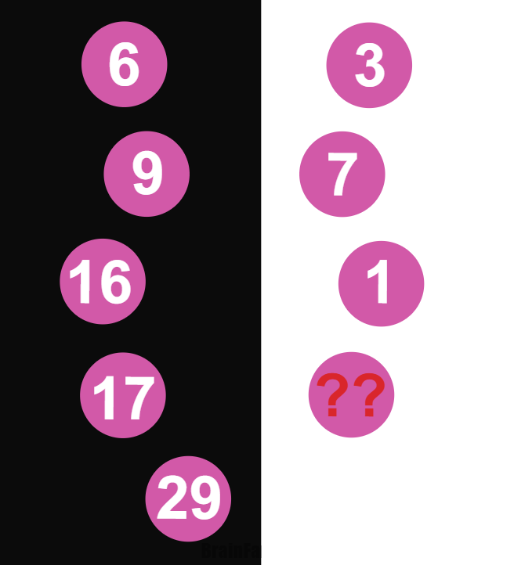

Answer: **12**

If you read the numbers per lines, you get:

6+3=9

9+7=16

16+1=17

17+??=29

**4.**

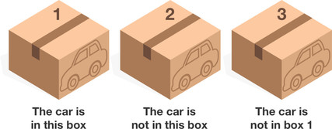

There are 3 boxes, exactly one of which has a car. You can keep the car if you pick the correct box!

On each box there is a statement**, exactly one** of which is true.

Box 1: The car is in this box.

Box 2: The car is not in this box.

Box 3: The car is not in box 1.

Which box has the car?

A. Box 1

B. Box 2

C. Box 3

**=>** Correct answer: **B** - Box 2

If Box 2 contains the car, then the statement on Box 2 would be False (it is in box 2!), the statement on Box 1 would be False (it's not in box 1), and only the statement on Box 3 is True (yes, the car is not in box 1). Thus, it looks like the car is in Box 2!

But, let's rule out the other possibilities to double check!

If Box 1 contains the car, then the statements on both Box 1 and Box 2 are true, so this is impossible.

If Box 3 contains the car, then the statements on both Box 2 and Box 3 are true, so this is impossible.

**5.**

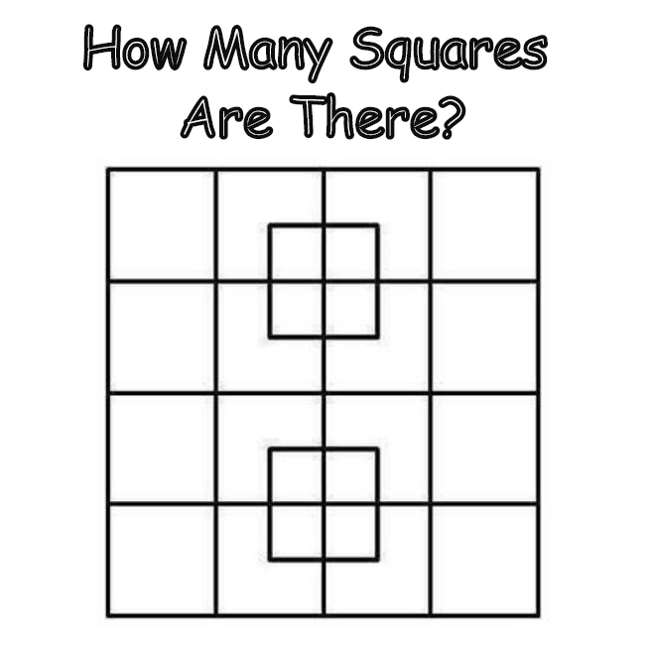

Answer: 40

**6.** What is the output?

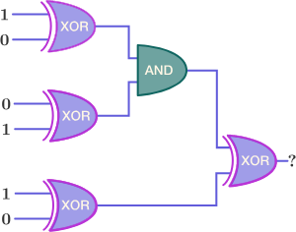

A. 0

B. 1

-> Correct answer: **A**. 0

**7.** Assume that you are playing a Tic-tac-toe game with an opponent. You are playing as while your opponent plays as .

The game is played as follows:

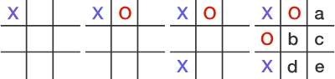

Find all the possible grid tiles where you can put an -mark that will help you guarantee yourself a win under best play.

A. a

B. b

C. c

D. d

E. e

F. Either a or b

G. Either b or e

-> Correct answer: **G** - Either b or e

Placing an X in the center (location b) sets up two possible winning moves (a and e) which cannot both be prevented by the other player.

Similarly, placing an X in the lower right cell (location e), this also sets up two possible winning moves (b and d) which again cannot both be prevented by the other player. As a result, if X places in either b or e, then player X will be guaranteed a winning move on his or her following turn.

(NOTE: a doesn't work here. O responds at b threatening to win at both c and d simultaneously, and X can only block one of them. O then plays at the other to win.)

**8.** What is the size of ‘int’?

[A. 2](javascript:void(0);)

[B. 4](javascript:void(0);)

[C. 8](javascript:void(0);)

D. Compiler dependent

Correct answer: D - Compiler dependent

The size of ‘int’ depends upon the complier i.e. whether it is a 16 bit or 32 bit.

**9.** Which library function can convert an unsigned long to a string?

A. ltoa()

B. ultoa()

C. system()

D. unsigned long can’t be converted to a string

Correct answer: **A** - ltoa()

**10.** What will be the output of the program ?

#include<stdio.h>

int main()

{

struct { int x;} var = {5}, *p = &var;

printf("%d %d %d", var.x, p->x, (*p).x);

return 0;

}

A. 5 5 5

B. 5 5 garbage value

C. 5 5 0

D. Compile error

=> Correct answer: **A**. 5 5 5

**11**. Which of the following services use TCP?

1. DHCP 2. SMTP 3. HTTP 4. TFTP 5. FTP

A. 1 and 2

B. 2, 3 and 5

C. 1, 2 and 4

D. 1, 3 and 4.

**=>** Correct answer **B.** 2, 3 and 5

**12.** Which type of constructor can’t have a return type?

A. Default

B. Parameterized

C. Copy

D. Constructors don’t have a return type.

Correct answer: D. Constructors don’t have a return type

Constructors don’t return any value. Those are special functions, whose return type is not defined, not even void. This is so because the constructors are meant to initialize the members of class and not to perform some task which can return some value to newly created object.

**13**. To sort many large object or structures, it would be most efficient to:

A. Place them in an array and sort the array

B. Place them in a linked list and sort the linked list

C. Place pointers to them in an array and sort the array

D. Place reference to them in and array an sort the array

Correct answer: **B**. Place them in a linked list and sort the linked list

**14.** When using the SQL INSERT statement:

A. rows can be modified according to criteria only.

B. rows cannot be copied in mass from one table to another only.

C. rows can be inserted into a table only one at a time only.

D. rows can either be inserted into a table one at a time or in groups.

=> Correct answer: **D**. rows can either be inserted into a table one at a time or in groups.

**15.** (SQL) To sort the results of a query use:

A. SORT BY

B. GROUP BY

C. ORDER BY

D. None of the above is correct

=> Correct answer **C**

**16**. How many instances of an abstract class can be created?

A. 1

B. 5

C. 13

D. 0

=> Correct answer **D**. 0

Cannot create an instance of the abstract class or interface

**17**. Structured Query Language (SQL) is an internationally recognized standard language that is understood by all commercial database management system products.

A. True

B. False

=> Answer A

**18.** How many swaps are required to sort the given array using bubble sort - {5, 1, 4, 2, 8}

A. 7

B. 4

C. 6

D. 5

=> Correct answer: **B. 4**

There will be 3 swaps in first iteration and 1 swap in second iteration

First Pass:

( 5 1 4 2 8 ) –> ( 1 5 4 2 8 ), swap since 5 -> 1

( 1 5 4 2 8 ) –> ( 1 4 5 2 8 ), Swap since 5 > 4

( 1 4 5 2 8 ) –> ( 1 4 2 5 8 ), Swap since 5 > 2

Second Pass:

( 1 4 2 5 8 ) –> ( 1 2 4 5 8 ), Swap since 4 > 2

**19.** In HTTP pipelining:

A. multiple HTTP requests are sent on a single TCP connection without waiting for the corresponding responses.

B. multiple HTTP requests can not be sent on a single TCP connection.

C. multiple HTTP requests are sent in a queue on a single TCP connection.

D. none of the mentioned.

=> Correct answer: **A**. multiple HTTP requests are sent on a single TCP connection without waiting for the corresponding responses.

**20**. Predict output of following program

#include<stdio.h>

int fun(int n)  
{  
 if (n ==5)

return n;

else return 2*fun(n+1);   
}

int main()  
{  
 printf(“%d ”, fun(2));

return 0;  
}

1. 4
2. 8
3. 16
4. 40
5. Runtime Error

=> Answer: 40

fun(2) => 2*fun(3) => 2* 2 * fun(4) => 2* 2 * 2 * fun(5) => 40

Question: *How would you describle yourself? And what are your short-term job goals?*

***----------------- Thank you! ------------------***